Child and Adult Food Program FFY 2024 Public Release
Participating Agencies
Division of Food and Nutrition

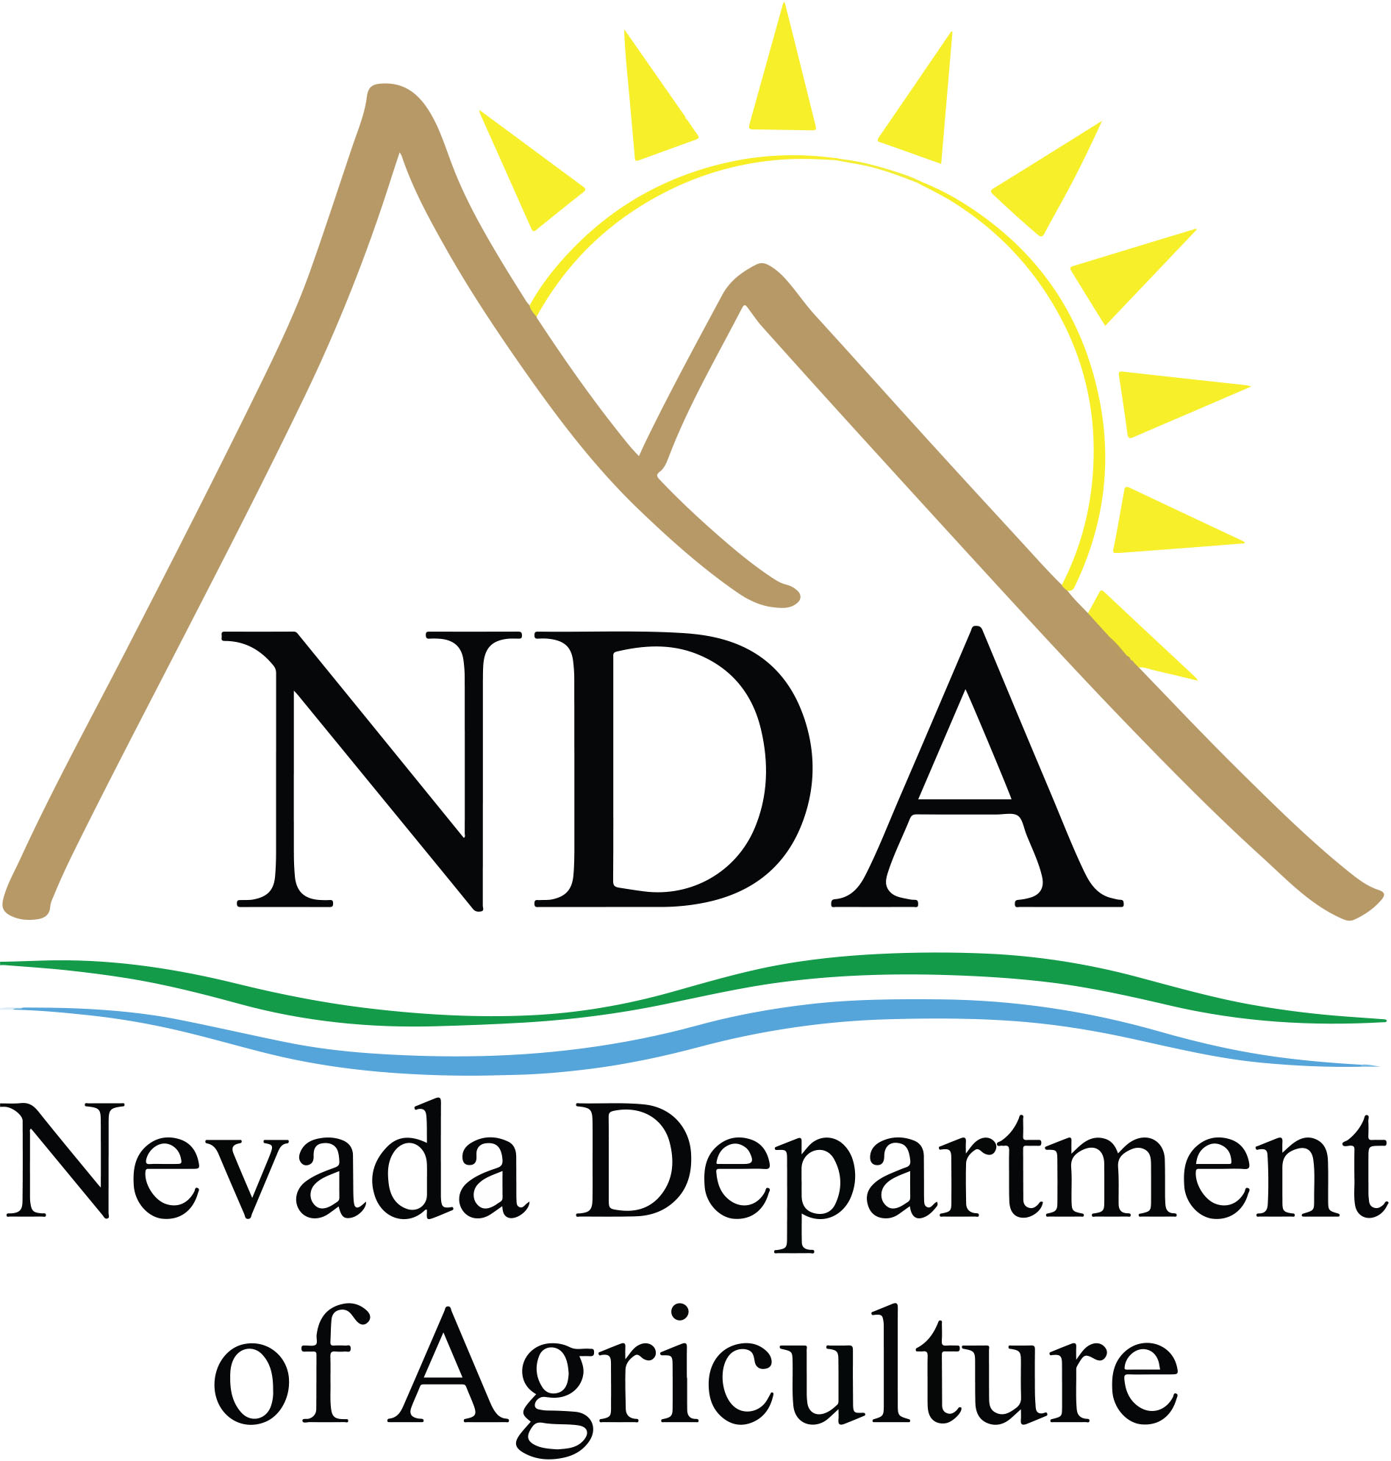

 | COUNTY |  | CITY |  | AGENCY
 | Churchill |  | Fallon |  | The Fallon Youth Club Inc.
 |  |  | Fallon |  | US Naval Station Morale Welfare & Recreation CDC
 |  |  | Fallon |  | Boys & Girls Club of Truckee Meadows
 | Clark |  | Las Vegas |  | Almost Home Adult Care LLC
 |  |  | Las Vegas |  | ChildTime Learning Centers
 |  |  | Las Vegas |  | Clark County School District At Risk Meals
 |  |  | Las Vegas |  | Creative Beginnings, Inc. dba Kids First
 |  |  | Las Vegas |  | Imagination Station Early Learning Center LLC
 |  |  | Las Vegas |  | Kids Cove Preschool and Child Care Inc.
 |  |  | Las Vegas |  | KinderCare Education LLC
 |  |  | Las Vegas |  | La Petite Academy
 |  |  | Las Vegas  Las Vegas  Las Vegas |  | Nevada Adult Day Healthcare Centers Inc.  NADHC at Eastern, Inc.  NADHC at the ACSC, Inc.
 |  |  | Las Vegas |  | Nevada Senior Services Inc.
 |  |  | Las Vegas |  | Redeemer Lutheran Church of Las Vegas
 |  |  | Las Vegas |  | Sigman Enterprises Inc. dba Watch Me Grow
 |  |  | Las Vegas |  | Silver Town Inc.
 |  |  | Las Vegas |  | Three Square
 |  |  | Las Vegas |  | USAF Nellis Child Development Centers
Elko |  | Elko  Jackpot |  | Elko County School District At Risk Meals  Elko County Human & Social Services
Carson City |  | Carson City |  | Boys & Girls Clubs of Western Nevada
Humboldt |  | Winnemucca |  | Boys & Girls Club of Truckee Meadows
Lyon |  | Dayton |  | Calvary Chapel Dayton Valley
 |  | Dayton |  | Boys & Girls Club of Mason Valley Inc.
 |  | Hawthorne |  | Boys & Girls Club of Mason Valley Inc.
 |  | Silver Springs |  | Boys & Girls Club of Mason Valley Inc.
 |  | Yerington |  | Boys & Girls Club of Mason Valley Inc.
 |  | Fernley |  | Boys & Girls Club of Truckee Meadows
Washoe |  | Reno |  | Boys & Girls Club of Truckee Meadows
 |  | Reno |  | KinderCare Education LLC
 |  | McCarran, Reno |  | The Food Bank of Northern Nevada, Inc.
White Pine |  | Ely |  | Boys & Gils Club of Truckee Meadows
STATEWIDE SPONSORS
Food For Kids, Inc./ Day Care Homes
Food For Kids, Inc./Unaffiliated Child Care Centers and Adult Day Care Centers

HEAD START (HS) AGENCY SPONSORS

Acelero Learning Clark County:
1. Las Vegas 3. North Las Vegas
2. Henderson

Centro de la Familia de Utah:
1. Fallon 2. Yerington

Community Services Agency:
1. Reno 3. Fernley
2. Sun Valley 4. Sparks

Head Start of Northeastern Nevada:
1. Elko

Little People’s Head Start in Ely

Reno-Sparks Indian Colony

Sunrise Children’s Foundation
1. Henderson 3. North Las Vegas
2. Las Vegas

Washoe Tribe of Nevada/California:
1. Dresslerville
2. Carson City - Stewart

